Customer Churn Prediction using Machine Learning
1. Objective
The objective of this project is to build a supervised machine learning model to predict whether a customer is likely to churn or not. This helps businesses take proactive steps to retain customers.

2. Dataset
The dataset used is the Telco Customer Churn Dataset.
It contains customer details such as:
- Demographics (gender, senior citizen)
- Account information (tenure, contract type)
- Services (internet service, phone service)
- Target variable: Churn (Yes/No)
- 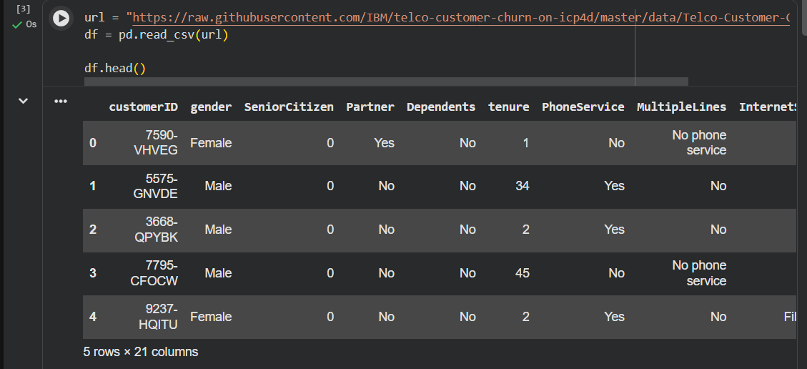

3. Data Preprocessing
The following preprocessing steps were performed:
- Converted “TotalCharges” column to numeric format
- Handled missing values by replacing them with 0
- Converted categorical variables into numerical values using Label Encoding
- Split dataset into training (80%) and testing (20%) sets
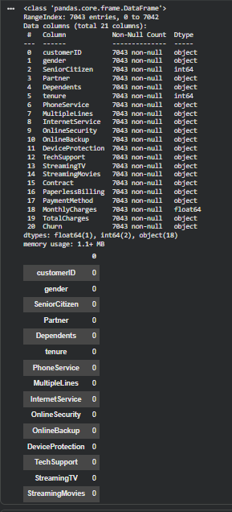

4. Models Used
Two machine learning algorithms were implemented:
4.1 Logistic Regression
- A linear model used for binary classification
- Simple and interpretable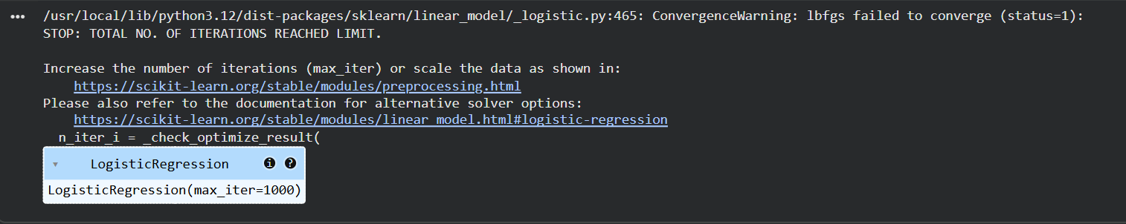
4.2 Random Forest Classifier
- Ensemble learning method using multiple decision trees
- Handles complex and non-linear relationships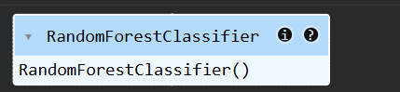

5. Evaluation Metrics
The models were evaluated using the following metrics:
- Accuracy – Overall correctness of the model
- Precision – Correct positive predictions
- Recall – Ability to detect actual positives
- F1 Score – Balance between precision and recall
- ROC-AUC Curve – Performance across different thresholds

6. Results
Logistic Regression Performance
- Accuracy: 0.8161816891412349
- Precision: 0.6737804878048781
- Recall: 0.5924932975871313
- F1 Score: 0.630527817403709
Random Forest Performance
- Accuracy: 0.7977288857345636
- Precision: 0.6549295774647887
- Recall: 0.4986595174262734
- F1 Score: 0.5662100456621004
Cross-Validation Scores
- Logistic Regression: 0.804061753984128
- Random Forest: 0.7939816681721401

7. Visualization
The following visualizations were generated:
- ROC Curve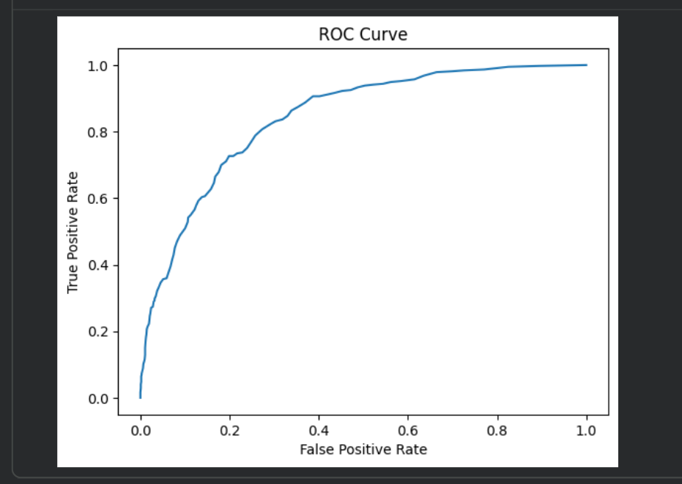
- Confusion Matrix
- 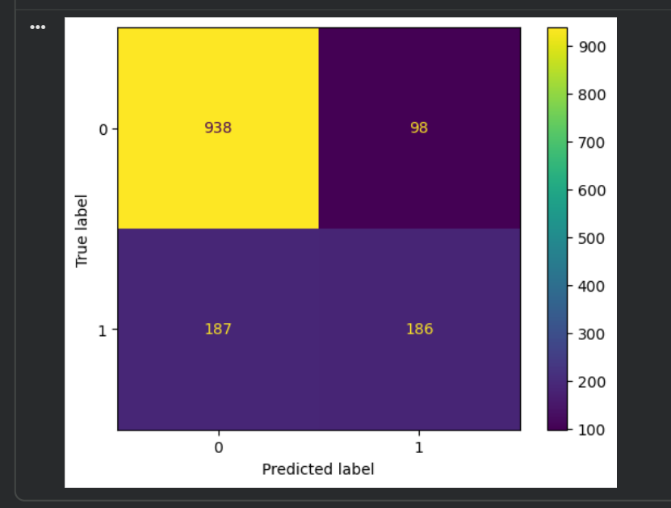
These helped in understanding model performance visually.

8. Conclusion
Based on the evaluation metrics, the Random Forest Classifier performed better than Logistic Regression. It achieved higher accuracy and F1 score, making it more suitable for this dataset.

9. Future Improvements
- Hyperparameter tuning to improve model performance
- Use of advanced models like XGBoost
- Deployment of the model using an API

10. References
- Dataset source
- Python libraries: Pandas, NumPy, Scikit-learn, Matplotlib

